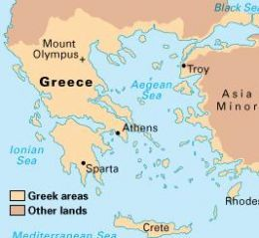

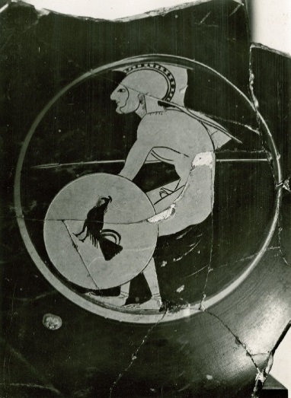

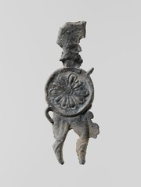

SPARTA

Government:

* Sparta had 2 kings and a council of 28 men to rule the city state
* All men over 30 got to vote

Warfare:

* Sparta had the best land army
* All citizens in Sparta took part in very strict military training from the age of 7
* Sparta invaded Attika and burnt crops

ATHENS

Government:

* Athens had a democracy which meant that all men had the chance to vote
* Athens was the world’s first democratic government

Warfare:

* The Athenians were good at fighting at sea and had the best fleet
* After the Persian Wars Athens rebuilt walls around the city to protect it
* Athens and Sparta were enemies
* They fought against one another in the Peloponnesian War
* Other city-states took sides and fought with either Athens or Sparta
* The war took place between 431-404 BC
* Thucydides the historian wrote about the war
* The Athenians surrendered in 404 BC

**The Peloponnesian War: Key Facts**